1. **Identify five UI/design things that work in similar sites**
   1. Easy to sign up.
   2. Looks neat
   3. Contents orientated
   4. Clear graphics
   5. interactive
2. **Identify five bad/things that don't**
   1. Too messy
   2. Too crowded
   3. Wrong font size
   4. Too much/little contents
   5. Cannot find navigation
3. **Describe the new client site in one sentence**

The site should be distinctive in terms of its targets and goal. Clear layouts and Easy navigation.

1. **Identify who you feel is the target audience -- different members of the groups can have different opinions on that.**

The target audience will be foreign students who intend to participate in the English learning from U.S. volunteers. Another target audience will be the volunteers. And also future donators.

**Benefit of the design**

* Clear of contents,
* Easy sign up and login
* Bright color
* Spacious design
* Very easy navigation of courses

The desktop version:

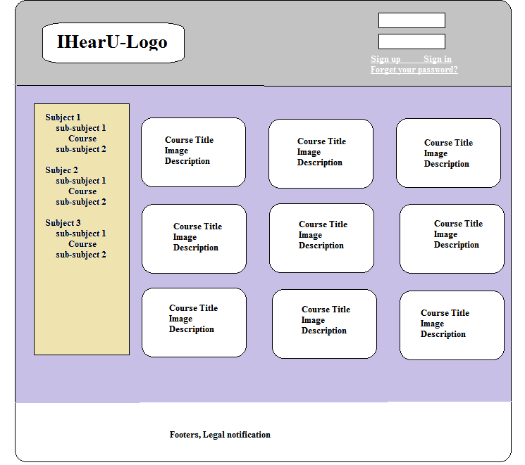

The mobile version

